ABSTRACT
Silver light is a term used to describe the brightness, luminosity, and color of light that is associated with silver. It can be observed when light strikes a smooth or polished surface of silver, resulting in a bright and shiny appearance. Silver light can also refer to the characteristic color or quality of light associated with silver, such as the cool, silvery hue of a full moon. In photography, silver light refers to the light-sensitive emulsions used in traditional film processing.
The abstraction of silver light involves representing or capturing its essence in a simplified or conceptual form through various mediums such as art, literature, or science. Abstraction can help us better understand the nature of silver light and its behavior in different contexts. Ultimately, the term silver light conveys the unique and distinctive qualities of light associated with silver, whether in its reflective properties or its perceived color or hue.

ii

REFERENCES

      - www.netikatech.com

      - www.silverlight.net

      - www.componentone.com

4 . www.wikepedia.com

1.INTRODUCTION

Microsoft Silverlight is a new cross browser, cross platform client technology that is used to design, develop and deliver media enabled interactive applications on the web and is Microsoft’s answer to Adobe Flash.

Silverlight can be used by both designers and to developers because it provides a powerful platform that makes it easy to develop web applications with professional quality graphics, audio and video for an engaging user experience. Silverlight also offers powerful tools that will improve the productivity of both designers and developers.

Silverlight aims to compete with Adobe flash and the presentation components of AJAX. It also competes with Sun Microsystems’s JavaFX, which was launched a few days after Silverlight. The first CTP of Silverlight was released in dec2006.Microsoft aims to have a final released by mid-2007.An unattributed report
claimed that Microsoft aims to release certain parts of Silverlight source code as open source software, but the claim has been denied by Microsoft. Sam Ramji, Microsoft director of platform technology strategy, Said Microsoft has know plans to open source Silverlight. However, portions of the dynamic Language Runtime, included with Silverlight have been made available on Microsoft’s codeplex website using the Microsoft Permissive License.

2.OVERVIEW

Web based applications have often represented a compromise between creating a high quality user interface and that amount of effort and the time that a development team can put into the application. Developers generally believe that browser simply do not support. The interactive and the expressive capabilities of a true client based application the result is that web based application often do not take full advantage of the capabilities of the users computer to provide an experience that users find not just functional ,but exciting.

But now one can use Microsoft Silverlight. Silverlight is a new cross browser, cross platform implementation of the .NET framework for building and delivering the next generation of media experience and rich interactive application for the web. Silverlight unifies the capabilities of the server, the web, and the desktop, of managed code and dynamic languages, of declarative and traditional programming and the power of windows presentation foundation. Silverlight offers great productivity through familiar tools and technologies based on the .NET framework

3.WHAT IS SILVERLIGHT?

Silverlight combines multiple technologies in to a single development platform that enables a developer to select the right tools and the right programming languages for his needs. Silverlight offers the following features.

  - Microsoft announced its IIS7 Media Pack, which adds features such as rate throttling and others designed to further reduce the cost of media distribution. The IIS7 Media Pack will be a free download for Longhorn customers when it ships later this year, the company said.
  - Several media companies and solution providers have announced support for Silverlight, including Akamai, Brightcove, Eyeblaster, Limelight, Major League Baseball, Netflix, Skinkers, Sonic Solutions, SyncCast, Tarari and Telestream. All have said they plan to deploy Silverlight-based experiences for their viewers and customers.
  - In a statement, Brightcove said: "Silverlight uses Windows Media Video (WMV) and brings the VC-1 video standard to the browser, a standard also used for HD DVD, Blu-ray Disc, Xbox 360 and Windows Vista. Brightcove already supports Flash Video 7 and 8 as well as WMV 9 for downloadable video. By adding Silverlight and VC-1 support, the Brightcove Internet TV service will provide media owners with another powerful Internet video output format - one that comes with robust content protection through a native DRM solution."
  - At the discretion of content providers, Silverlight will also deliver digital rights management support built on the recently announced Microsoft PlayReady content access technology - with feature parity on Windows and the Mac, Key said.

  - As for the name "Silverlight," Key said the name for the technology formerly known as WPF/E "had to have very broad consumer resonance," as the target audience for the technology consists of consumers, media companies, and professional developers and designers.

SL FOR MOBILE: SCHEDULE



FIG (1): SILVER LIGHT FOR MOBILES

4.RELEASES

The latest release is version 1.0 beta, with an alpha release of version 1.1 made available as well. The runtime is available for windows XP, windows server2003, windows vista and Mac OSX 10.4, with browser plugins available for internet explorer 6.0/7.0,firefox 1.5/2.0 and safari 2.0opera is not supported in the current releases but will be supported with future builds as will be windows 2000.additional platforms are being considered as well.

4.A A Silverlight1.0 application hosted in internet Explorer

A Silverlight 1.0 consists of the core presentation framework, which is responsible for UI, interactivity and user input, basic UI controls, graphics and animation, media payback, DRM support, and DOM integration. it is made up of the following components.

    - Input-handling input from devices like keyboard, mouse, stylus etc.
    - UI core-managing rendering of bitmap images vector graphic, text and animation.
    - Media-playback of MP3, windows media and VC-1 streams.
    - XAML-to allow the UI layout to be created using XAML markup language.

A silver sight application start by invoking the Silverlight control from the html page which then loads up a XAML file contains a canvas object, which acts as place holder for other elements. Silverlight provides various geometrical primitives like lines, ellipse and other shapes; to element like text, images and media etc. the elements are properly positioned to achieve the desired layout. any arbitrary shapes can be created as well. These elements can be animated using event triggers. Some animation effects are pre defined, other can be created as composite of the composite effects. Events like keyboard or mouse movements can also raise events which can be handled by custom scripts.
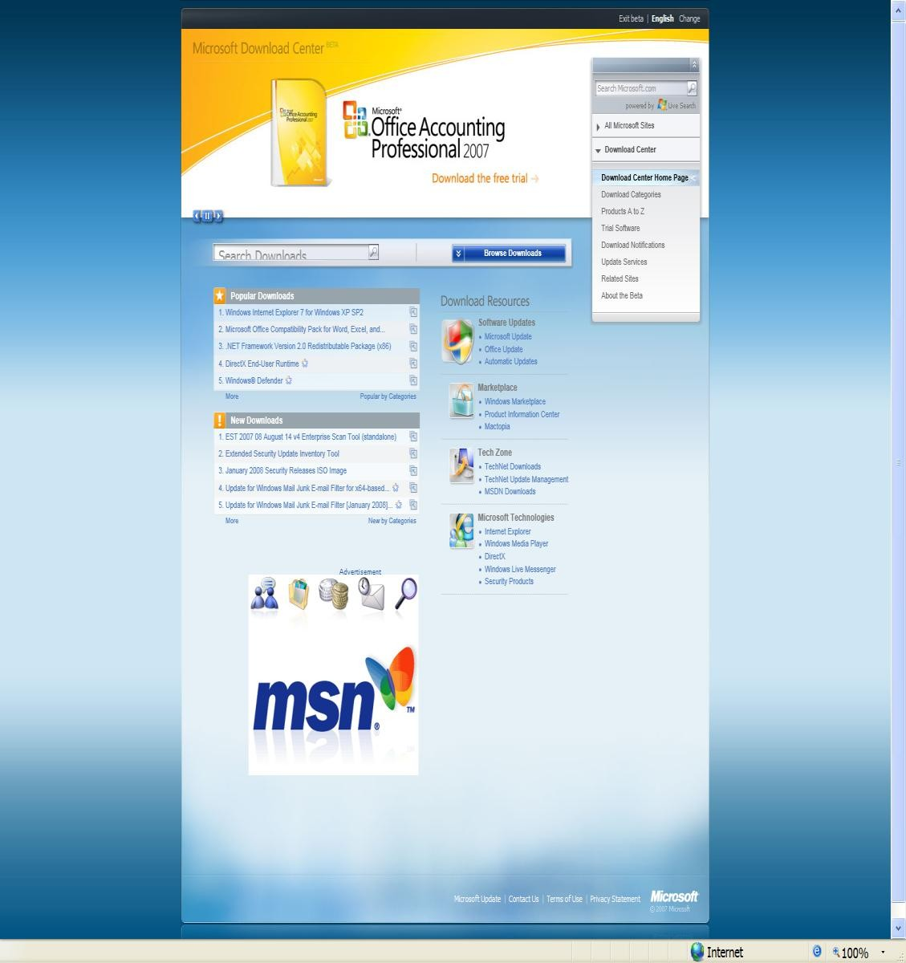

Fig(2) : Demo: MS Download Center

Beta interface to MS Download Center is done with Silverlight 1.0

4.B A Silverlight 1.1 application hosted in internet Explorer

Silverlight1.1 includes a version of the .NET framework, with the full common language runtime as .NET framework 3.0, so it can execute any .NET language including VB.NET and c# code. Unlike the clr included with >NET framework, multiple instance of the core CLR included in Silverlight can be hosted in one process. With this the XAML layout markup file can be augmented by code behind code, written in any
.NET language, which contains the programming logic. it can be used to programmatically manipulate both the silver light application and the HTML page which host the silver light control. Silverlight ships with the light weight class library ,which features among others. Extensible control, XML web services, networking components and LINQ APIs. this class library is a subset of and is considerably smaller than .NET frameworks base class library. Silverlight codes runs in a sandbox which prevents invoking platforms APIs. Silverlight 1.1 also add support for DRM in media files.

The version of .NET framework in Silverlight adds a subset of WPF UI programming model, including support for shapes, documents, media and animation objects of WPF. However the set of UI controls Silverlight ships with in the current release in limited. Also in the current release the UI controls do not have support for data binding to any data source. But Microsoft has clarified that the limitation are due to this being an early +preview release. Future releases will add more UI controls are being made available for the current alpha release as well.


Fig(3) : Demo: Silverlight Airlines

Silverlight Airlines: v1.1 sample implemented with C# code-behind Demonstrates: scalability, animation, whole page is SL.

5.FEATURE OF SILVERLIGHT APPLICATIONS

 It is a cross browser, cross platform technology. It runs in all popular web browsers, including Microsoft internet explorer, Mozilla Firefox, apple safari and opera, on Microsoft windows and apple Mac OS X.

It provides a consistent experience no matter where it runs.

It is supported by a very small download that installs in second.

It streams video and audio. It scales video quality it every thing from mobile devices o desktop browsers to 720pHDTV video modes.

It includes compelling graphics that users can manipulate drag turn and zoom directly in the browser.

It reads data updates the display, but it does not interrupt the user by refreshing the whole page.

6.SILVER LIGHT ARCHITECTURE

The included Base Class Library (BCL) provides classes for collections, reflection, regular expressions, string handling and data access. It also supports LINQ, with the full support for LINQ to object and expression trees. Almost all of the systems are LINQ system. LINQ .expression namespaces are exposed. HOWEVER, LINQ to XML is not present in the Silverlight 1.1Alpha release, through further releases of silverlight1.1 will include it. It also supports serialization of objects, for data persistence. Silverlight can handle data in RSS, POX and JSON formats in addition to XML. The BCL provides enhanced support for working with XML data including the XML reader and XML writer classes. Silverlight also includes classes for data access over XML- based web services (POX), REST and WCF services. The networking support in the Silverlight can be used by Silverlight applications to communicate over HTTP However in the current release of Silverlight 1.1, cross domain communication is not allowed. Silverlight also supports asynchronous programming via the use of the threading libraries.

Silverlight 1.1 is distributed with the dynamic language runtime which allows dynamic compilation and execution of dynamic (scripting) languages. The first available languages written for the DLR are managed Jscript and IronPython 2.0.Microsoft is also building IronRuby and dynamic Visual Basic (VBX) languages.
Silverlight 1.1 also allows limited file system access to Silverlight applications. It can use the operating systems native open file dialog box to browse to any file(which the user has access to).the file will be sanitized of path information to prevent the application from getting access to information like user name. It will be opened in read-only mode. For location storage of data, Silverlight provides isolated local storage (iso storage), which is stored outside the browser cache, in a hidden folder inside the user profile’s folder. In the current releases iso storage is limited to 1MB per URL, though this limit will later be made configurable. Data stored by a Silverlight application, identified by the URL that it loads from, can be accessed by the application only.
6.A RUNNING SILVERLIGHT APPLICATIONS

Silverlight based applications runs in all modern browsers, without having to create browser specific code. To run a Silverlight based application, users requires a small plug-in their browser. The plug-in is free. If users don’t already have the plug in, they are automatically prompted to install it. The download and installation takes seconds and require no interaction from the user except permission to install.

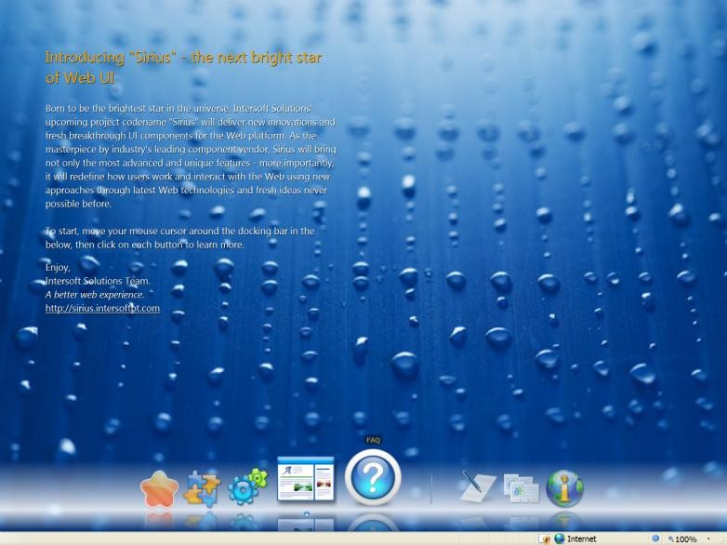

Fig(4) : Demo: 3rd Party Control Vendor

6.B Creating Silverlight Applications

You can create Silverlight based application using skills you already have and tools that you are already familiar with. You can create web pages that use both HTML and WPF elements with Silverlight. Like HTML, XAML enables you to create UI for your web based application with declarative syntax, with the difference that XAML provides significantly more powerful elements.

7.RELATED TECHNOLOGY AND TOOLS

Because Silverlight based application are cross-platform they run in most modern web browsers including the following.
- Microsoft internet explorer versions 6.0 and 7.0
- Mozilla Firefox versions 1.5 and 2.0
- Apple safari version 2.0
- The following Microsoft applications include special features for Silverlight development:
- Microsoft expression Blend. This tool can be used to create and modify the presentation layer of an application by manipulating the XAML canvas and controls, working with graphic and programming the presentation layer with a dynamic language such as JavaScript.
- Visual studio code names “Orcas” beta (VS2007).visual studio provides productivity tools for applications using language such as c# and Visual Basic. All the existing features of visual studio includes Silverlight specific features of visual studio are available for Silverlight specific features including intellisense, debugging and Silverlight project templates that create and link all required files.
Because Silverlight based applications are executed in a run time environment on the client machine. No particular application is to be required to be installed on the server. However developers may find that their ability to create rich applications that integrate services and data from multiple sources on the server is enhanced by integrating the following types of services and server-side applications into their Silverlight based application.
- ASP.NET AJAX, this includes a set of controls, services and libraries for creating rich and interactive Web based applications.
- Microsoft ASP.NET features (May2007), this features set provides additional functionality to enhance ASP.NET AJAX applications.
- Microsoft windows communication foundation (WCF) services.
- Internet servers, including Microsoft internet information services (IIS) and the Apache web server.
- Internet based application and services, including Microsoft ASP.NET, PHP, Windows streaming media services, Windows live services and other open web services.

7. A Development tools

Silverlight applications can be written in any .NET programming language, as such, any development tools which can be used with .NET languages can work with Silverlight, provided they can target the Silverlight core CLR for hosting the application, instead of the .NET framework CLR. Microsoft has positioned expression Blend2.0 designing the UI of Silverlight applications. Visual studio 2008 can be used to develop debug Silverlight applications. However, the current beta release of Visual studio 2008 requires the visual studio tools for Silverlight (currently an alpha release) to create Silverlight projects and let the compiler target coreCLR. A Silverlight project contains the Silverlight.Js and creates silverlight.js files, which initializes the Silverlight plugins for use in HTML pages, a XAML file for the UI, and code-behind files for the application code. Silverlight applications are debugged in a manner similar to ASP.NET applications. Visual Studio CLR remote cross platform debugging feature can be used to debug Silverlight applications running on a different platform as well.

7. B Moonlight

The developers of mono framework, a free and open source equivalent of
.NET framework, are developing an equivalent open source implementation, with Linux support, under the temporary name moonlight. It is reported as expecting to over a feasibility “alpha” demo in mid-June 2007, with support for Firefox on Linux by the end of the year. A public demo was shown at Microsoft ReMIX conference in Paris, France on June 21, 2007.

7. C Criticism

Silverlight has been criticized for lack of Linux support-or indeed any platform other than Windows and MacOS X, citing it as a factor that could limit the widespread adoption of Silverlight. However, according to Mike Harsh, a program manager for Silverlight, Microsoft will eventually port Silverlight to Linux after the work has been completed on the windows and OSX platforms. Microsoft will probably not do it in-house, but rather choose to contract it out. Even though the runtime itself spans two client platforms, lack of any cross-platform development tools have also up as a point of concern.
It has also received criticism for ignoring existing international standards. According to Ryan Paul of Ars Technica, Microsoft could have chosen SVG to implement the vector graphics subset instead of a “limited and incompatible facsimile”, to show their commitment to open standards and also fix the standards problems that plagues internet explorer.
“Silverlight can be viewed as a web extension of the Windows Presentation Foundation (WPF), a .NET 3.0 technologies and not simply as a new web technology. As such, it makes sense that Silverlight uses XAML, not SVG. If Silverlight were based on SVG, then there would be a chasm between Silverlight and the .NET
framework, but as it stands Silverlight’s use of XAML makes the part of the .NET family.

7.D Core Presentation Components

The core presentation features of the Silverlight platform shown in the previous section and diagram, are listed in the following table with descriptions

Feature | Description
Input | Handles inputs from hardware devices such as the keyboard and mouse, drawing, other  input devices.
UI rendering | Renders vector and bitmap graphics,  animations and text.
Media | Features playback and management of  various type of audio and video files, such as .WMP and .MP3 files.
Controls | Provides for layout and editing of UI  controls associated with browsers.
DRM | Enables digital rights management of  media assets.

Table (1): core presentation features
    - MICROSOFT SILVERLIGHT: More Than A Flash
Microsoft gives a name to its Flash-killer technology. The technology formerly known as WPF/E is now known as Silverlight.

Microsoft has given a go-to-market name for its cross-platform, cross-browser plug-in for delivering the next generation of user experiences and rich Internet applications for the Web. The technology formerly known as WPF/E is now known as Silverlight.

Microsoft announced Silverlight at the National Association of Broadcasters conference in Las Vegas on April 16. The NAB announcement highlights Silverlight uses for media users. The software company will announce further details about the technology at its own Mix07 conference, which starts at the end of April and runs through May 2 in Las Vegas.

Forest Key, a director of product management in the Microsoft Server and Tools Division, said Silver light integrates with existing Web technologies and assets to provide higher quality experiences with lower costs for media delivery. In a briefing with eWEEK, Key demonstrated how Silverlight offers consistent experiences to both Mac and Windows users on a variety of browsers, including Internet Explorer, Firefox and Safari.

As for which platform Silverlight will support next, Key said, "Linux is an open question. We're looking at the desktops and browsers by volume. We want to put muscle behind supporting the bulk of the market." And Linux support is still under discussion, he said.
Silverlight uses WMV (Windows Media Video), Microsoft's implementation of the Society of Motion Picture and Television Engineers VC-1 video standard, ensuring compatibility with the millions of hours of content already available on the Web.
It also supports interactive video experiences from full-screen high-definition graphics to mobile scenarios.

Support for the VC-1 codec "means quite a number of surfaces support Silverlight, more than Flash," Key said, noting that Adobe's Flash - which is probably Silverlight's primary competition - has limited support for video.

"We have a unified codec that is open to the community," Key said. The VC-1 support means that content that is accessible via Silverlight on the PC is also accessible on the Xbox 360, on the Microsoft Zune, on HD systems, and on other devices or "surfaces" that support the codec, Key said.

Silverlight is based on the .Net Framework and enables developers and designers to use their existing skills to deliver media experiences and RIAs - which Microsoft refers to as "rich interactive applications" as opposed to "rich Internet applications" - for the Web with role-specific tools: Expression Studio for designers and Visual Studio for developers.

In addition to Silverlight, Microsoft announced Microsoft Expression Media Encoder, a feature of Microsoft Expression Media that enables rapid import, compression and Web publishing of digital video imported from a variety of popular formats, including AVI and QuickTime, into WMV. The encoder is capable of running on the desktop or a Windows Server.

Microsoft also announced hardware-accelerated video publishing using a Tarari appliance known as a Tarari Hardware-assisted Encoder Accelerator. Using the Tarari appliance, Expression Media Encoder speeds up encode times by up to 15 times over software alone, Key said.
And the Silverlight technology will provide even greater scalability with Windows Server, code-named Longhorn, as compared with Windows Server 2003. Indeed, Longhorn is expected to deliver up to twice the scalability, Microsoft said. Moreover,
Microsoft announced its IIS7 Media Pack, which adds features such as bit-rate throttling and others designed to further reduce the cost of media distribution. The IIS7 Media Pack will be a free download for Longhorn customers when it ships later this year, the company said.
Several media companies and solution providers have announced support for Silverlight, including Akamai, Brightcove, Eyeblaster, Limelight, Major League Baseball, Netflix, Skinkers, Sonic Solutions, SyncCast, Tarari and Telestream. All have said they plan to deploy Silverlight-based experiences for their viewers and customers.
In a statement, Brightcove said: "Silverlight uses Windows Media Video (WMV) and brings the VC-1 video standard to the browser, a standard also used for HD DVD, Blu-ray Disc, Xbox 360 and Windows Vista. Brightcove already supports Flash Video 7 and 8 as well as WMV 9 for downloadable video. By adding Silverlight and VC-1 support, the Brightcove Internet TV service will provide media owners with another powerful Internet video output format - one that comes with robust content protection through a native DRM solution."
At the discretion of content providers, Silverlight will also deliver digital rights management support built on the recently announced Microsoft PlayReady content access technology - with feature parity on Windows and the Mac, Key said.

As for the name "Silverlight," Key said the name for the technology formerly known as WPF/E "had to have very broad consumer resonance," as the target audience for the technology consists of consumers, media companies, and professional developers and designers.

9. FEATURES IN ACTION : DEMOS

Demo: Showcase

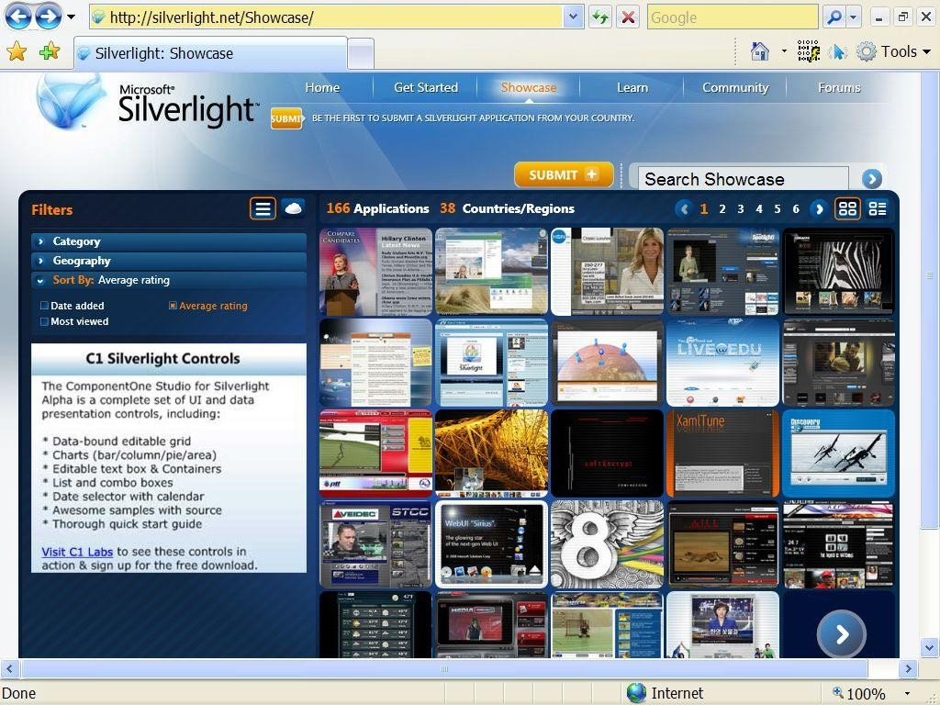

Fig(5): showcase
Demo: Deep Zoom

Fig (5): Deep zoom

Demo: Home Shopping Network

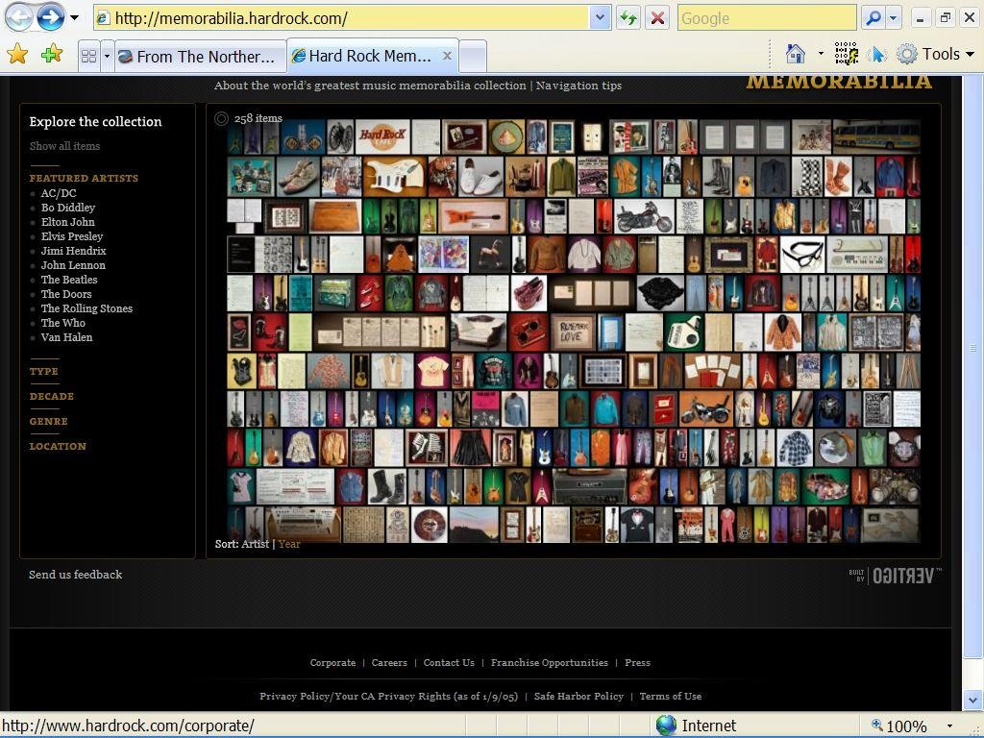

fig(6): home shopping network

Demo: SL 1.1 Chess App

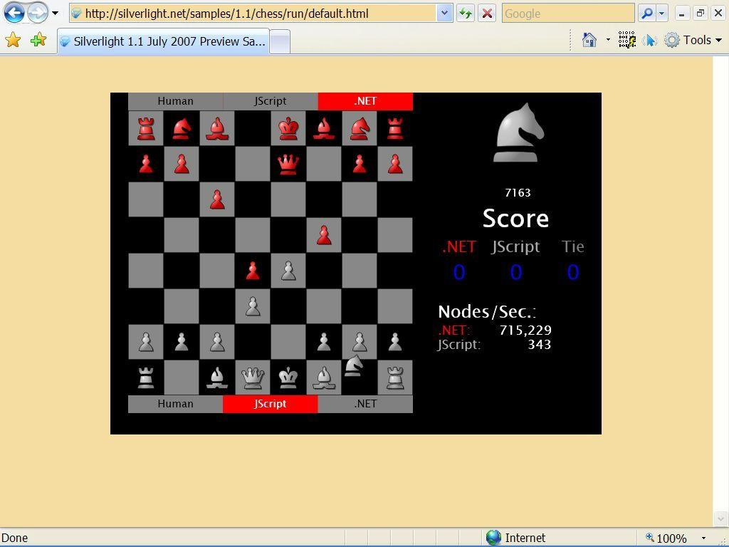

Fig (7): Sl 1.1 Chess application

9.CONCLUSION

Microsoft Silverlight, the alleged “Adobe Flash Killer”, is the new plugin platform for delivery of rich interactive media applications on the web and is currently available on windows and Mac OS X, supported by IE, Firefox and safari. High definition content will get better delivery support with WMV (windows media video).Silverlight streaming services has also been announced, wherein users and developers can host Silverlight content. A Linux version will be developed by Mono, an open source development platform for the .NET framework.

Whether Silverlight will gain ground over Adobe’s flash and other solutions for delivery of rich media experience remains to be seen.

